**Assignment 4 - Backend As a Service**

**GET:** <https://localhost:3443/favorites>

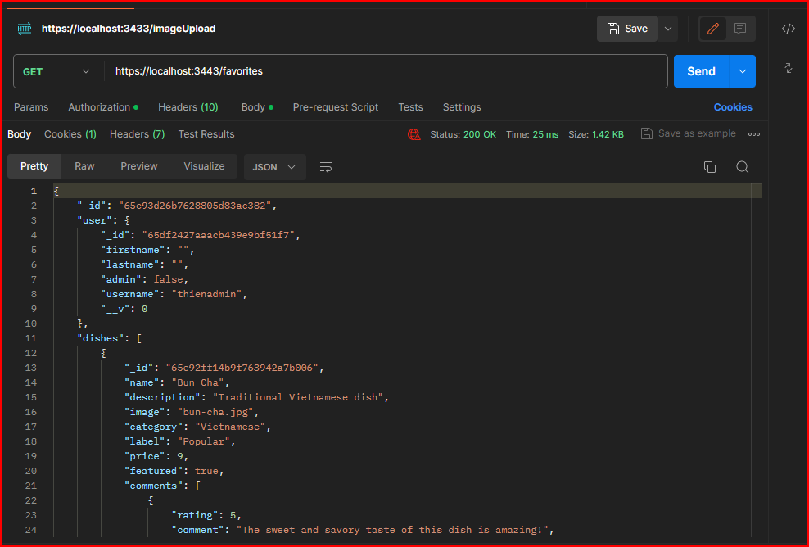

**POST:** <https://localhost:3443/favorites>

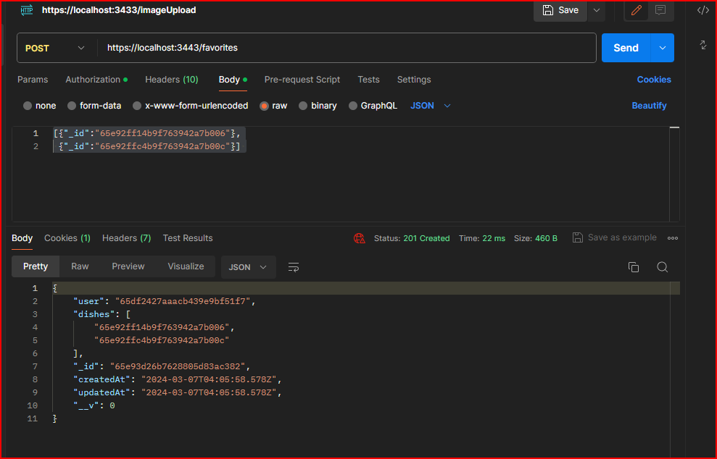

**DELETE:** <https://localhost:3443/favorites>

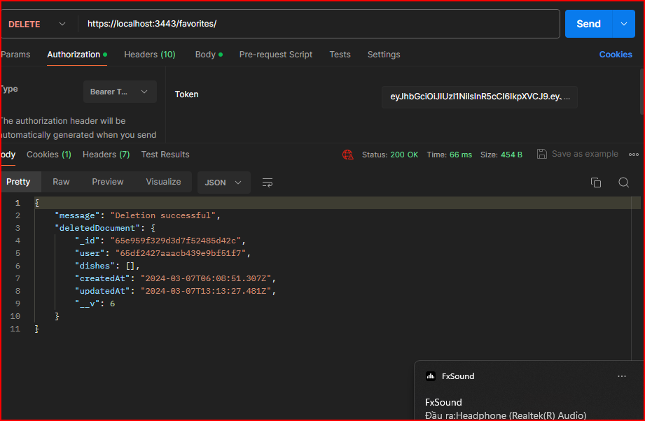

**GET:** <https://localhost:3443/favorites>/65e92ff14b9f763942a7b006

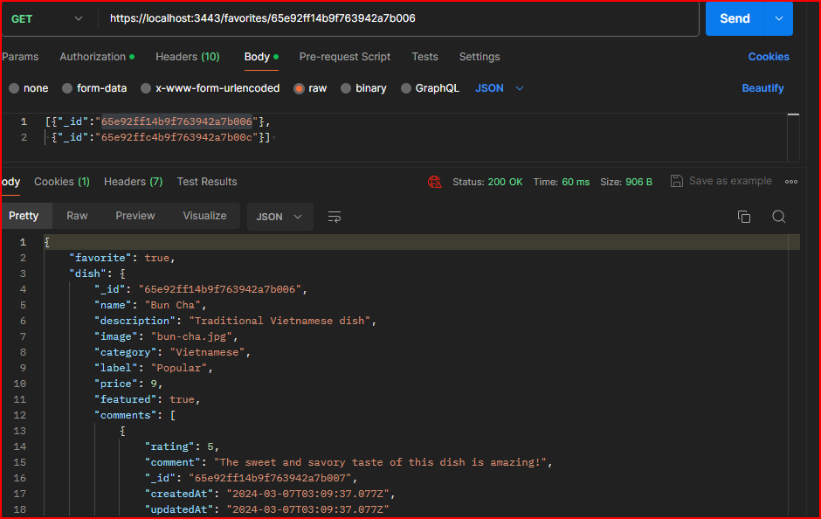

**POST:** <https://localhost:3443/favorites/65e92ff14b9f763942a7b006>

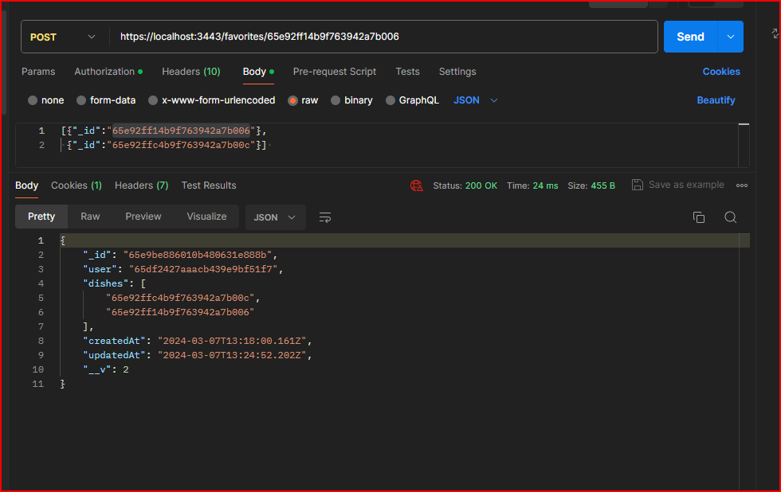

**DELETE:** <https://localhost:3443/favorites/65e92ff14b9f763942a7b006>

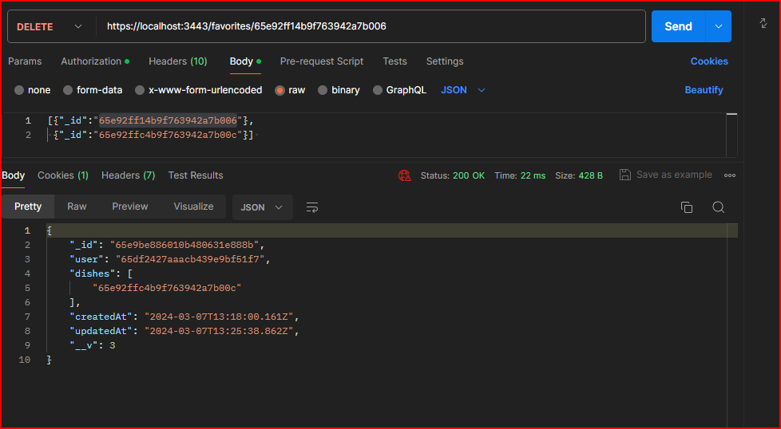

**AFTER DELETE:**

